**PROJECT TITLE : BITCOIN PRICES**

**INTRODUCTION**

* Bitcoin was created as a way for people to send money over the internet. The digital currency was intended to provide an alternative payment system that would operate free of central control but otherwise be used just like traditional currencies.
* Bitcoin is a decentralized digital currency that has experienced significant price volatility since its inception in 2009.
* Despite its relatively short history, Bitcoin has become a popular investment asset for individuals and institutions alike.
* The aim of this project is to develop an AI model that can accurately predict Bitcoin prices over time.
* The model will leverage historical Bitcoin price data as well as external factors that may influence Bitcoin prices, such as news sentiment scores, social media sentiment scores, and economic indicators.

**ABSTRACT**

* Cryptocurrency, an encrypted, peer-to-peer network for facilitating digital barter, is a technology developed eight years ago.
* Bitcoin, the first and most popular cryptocurrency, is paving the way

as a disruptive technology to long standing and unchanged financial payment systems that have been in place for many decades.

* While cryptocurrencies are not likely to replace traditional fiat currency, they could change the way Internet-connected global markets interact with each other, clearing away barriers surrounding normative national currencies and exchange rates.
* Cryptocurrencies may revolutionize digital trade markets by creating a free flowing trading system without fees. A SWOT analysis of Bitcoin is presented, which illuminates some of the recent events and movements that could influence whether Bitcoin contributes to a shift in economic paradigms.

**KEYWORDS**

Cryptocurrency, Bitcoin, Encrypted, Currency, Bitpay, Exchange Rates.

**STENGTHS**

* Bitcoin has strength by design to make it a viable currency that has elevated it in status over the years, more notably the fixed limit of bitcoin that will exist.
* Bitcoin will be mined with diminishing returns every four years until the maximum number of bitcoins are reached: a total of 21 million (King, 2013). This aspect of Bitcoin is important for its value.
* Protection From Payment Fraud. Bitcoins are digital currencies. ...
* Reduced Possibility of Identity Theft. Bitcoin transactions are completely anonymous. ...
* Immediate Settlement. ...
* Direct Transfer. ...
* Greater Liquidity. ...
* International Transactions. ...
* Security, Independent. ...

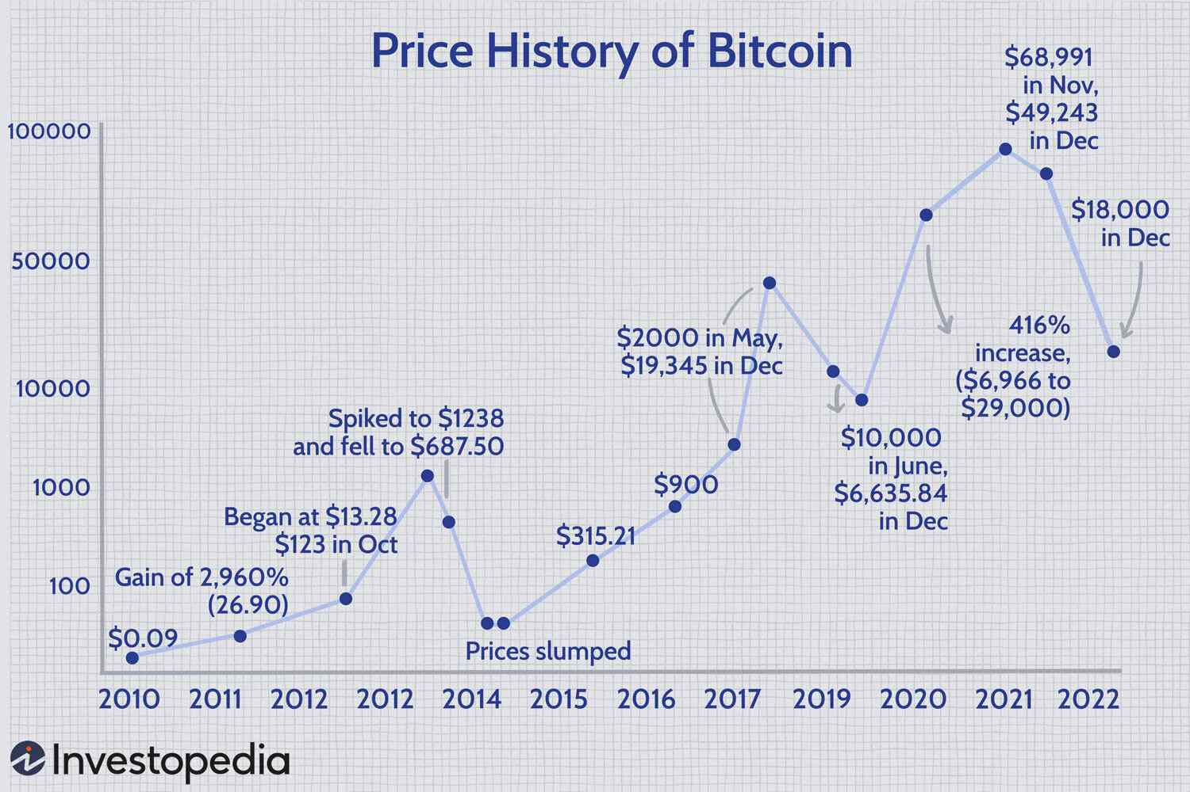

**WEEKNESS**

* Bitcoin's slow transaction times and high transaction costs prohibit it from being adopted for many day-to-day transactions. The high energy usage required by Bitcoin mining and the potential environmental effects are easy criticisms of the project often levied by detractors.
* Bitcoin has quite a few internal weaknesses that are part of its design and cannot easily be modified. The public ledger, or block chain, means that every user can see every transaction. There is semi-anonymity, in that the owners of bitcoin wallets cannot be identified outright, but it is slightly nerve-wracking for some potential adopters.

**OPPORTUNITIES**

* Cryptocurrency is in a unique position as a forerunner in a possibly transformative technology to long standing financial systems.
* "As an entirely decentralized form of currency, crypto has the potential to play a huge role in the future of global payroll and can remove the barriers of international hiring, allowing companies to easily manage globally distributed teams."
* Bitcoin Union is a platform that offers a new investment opportunity in the world of cryptocurrencies.

**THREATS**

* Bitcoin has quite a few hurdles to clear for user acceptance to become widespread. The value fluctuations that plague cryptocurrencies puts doubt in users, as well as investors. Ultimately a limiting factor in cryptocurrency is general acceptance. [PWC].
* **Cryptocurrency payments do not come with legal protections.** Credit cards and debit cards have legal protections if something goes wrong. For example, if you need to dispute a purchase, your credit card company has a process to help you get your money back. Cryptocurrencies typically do not come with any such protections.
* **Cryptocurrency payments typically are not reversible.** Once you pay with cryptocurrency, you can usually only get your money back if the person you paid sends it back. Before you buy something with cryptocurrency, know the seller’s reputation, by doing some research before you pay.